Lab 7

7.1 write a program to use of the property() function for the same Student class with the same functions defined as getter, setter and deleter which get all students information like above examples.
obj = Demo()
print(obj.get())

Source code
class student:

def __init__(self, fname, lname):
self.lname = lname
self.fname = fname
self.fullname = self.fname+" "+self.lname

@property
def fullname(self):
return self.fname + " "+self.lname

@fullname.setter
def fullname(self, name):
fname, lname = name.split(" ")
self.first = fname
self.last = lname

@fullname.deleter
def fullname(self):
self.first = None
self.last = None
print("Deleted the fullname")

def email(self):
return '{}.{}@gmail.com'.format(self.fname, self.lname)
return self.fullname+'@gmail.com'

s1 = student('Nabeel','Rizwan' )
print("Fullname of s1 is: ", s1.fullname)
print("Email of s1 is:", s1.email())

s2 = student('Hassan','Lodhi' )
print("Fullname of s2 is: ", s2.fullname)
print("Email of s2 is:", s2.email())

s3 = student('Hamza','Khan' )
print("Fullname of s3 is: ", s3.fullname)
print("Email of s3 is:", s3.email())

Output

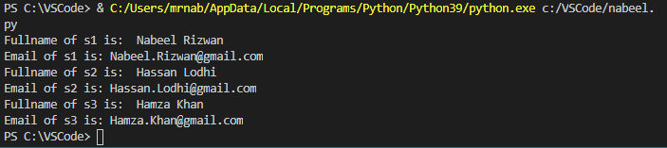

7.2 using property method, convert temperature which is in Celsius to Fahrenheit.

Source code
class convert:

def __init__(self, cels):
self.cels = cels

@property
def converter(self):
return self.cels*9/5+32

cels = input("Enter temperature in degeree: ")
cels = int(cels)

nabeel = convert(cels)
print("Temperature to celcius is: ", nabeel.converter)

Output

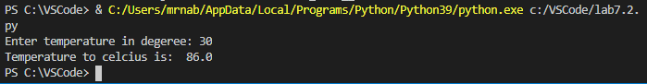

7.3 What is the output of the following code?
class Demo:
def __init__(self):
self.a = 1
self.__b = 1

def get(self):
return self.__b

Source code
class Demo:
def __init__(self):
self.a = 1
self.__b = 1

def get(self):
return self.__b

nabeel = Demo()
print(nabeel.get())

Output
